Dear Parent/Guardian,
Purpose:
This letter is intended to be sent to guardians after students have been registered for Odysseyware Academy.

Instructions:
- Replace the [highlighted text] with school-specific information.
- Modify the content as needed.
- REMEMBER to delete this text box before sending.
Your student has now been registered for online coursework through Odysseyware Academy. Congratulations!
Now what?
Your student should have received a Welcome email to their [personal/ school] email account. This email includes their login credentials and instructions for participating in Student Orientation. If your student has not yet received this email, please call 888-399-4267.
What technology does my student need?
Your student will need an Internet-connected computer. For best performance, Odysseyware Academy recommends the use of either Mozilla Firefox or Google Chrome.
How does my student get started?
Once your student logs in, they will arrive at the Dashboard. All courses in which your student is enrolled will be listed in the Academic Snapshot box.
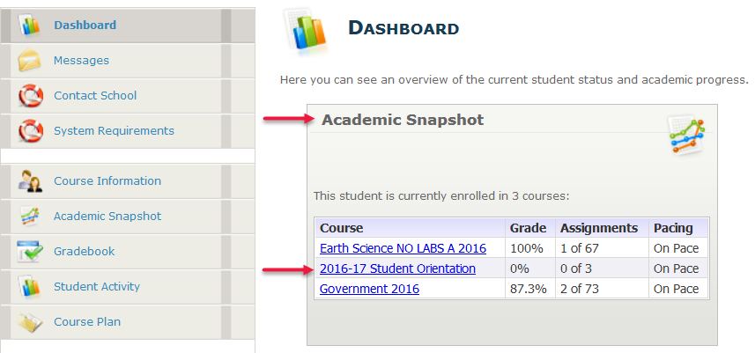
Your student should begin by completing the Student Orientation course. This 30-minute course will introduce the program, show how to complete schoolwork, and identify where to get help. Once orientation is complete, your student may continue with his/her other courses.
Can I see my student’s progress?
Absolutely, we would be happy to set up a Guardian account for you. All we will need is your name and a current email address. Please send this information to [email address]. Once your account has been set up, you will receive your own welcome email.
What will I see with my Guardian account?
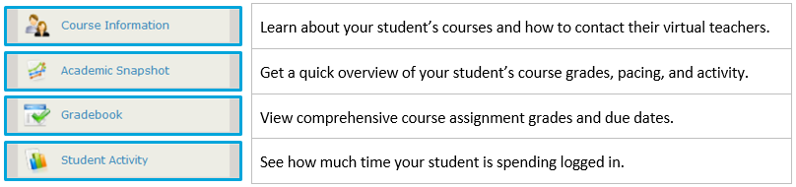
How will my student complete coursework?
Assignment Type | Passing | Attempts
Lesson | % | #
Quizzes | % | #
Tests | % | #

If your student does not meet the passing score on the first attempt, the system will automatically reassign the assignment up to the number of times listed above, or until the student meets the passing score.

Tips for Success
- Students should log in regularly and stay on pace as indicated in the Gradebook.
- Frequently view the academic snapshot to identify areas of improvement.
- For extended responses (such as essays), it is recommended that the student type the response in a word processor file (such as Word or Google Docs) and then copy/paste the response in their assignment.
- Stay on task. Students will be timed out of an assignment if they do not click on anything “clickable” (such as a button, or question response) within 25 minutes.
- If you need help, ask for it!
How do I or my student get help?
Students can send help requests to their teachers from within their assignments. Students and Guardians can also contact their teacher via email, phone, or by participating in the teacher’s online office hours (see Course Information or Gradebook for the link).
For technical support or other questions, call 888-399-4267.
We strongly recommend reviewing the Odysseyware Academy Student/Guardian Handbook located at the following link: https://goo.gl/vqDIzO
We know that support at home has a positive impact on student success. Thank you in advance for your support and feel free to contact us with any additional questions.
Sincerely
[School]

